EXPERIMENT 8

PRIME

MATRIX

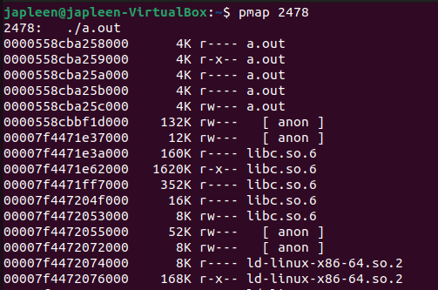

IO BOUND

